Using Cayuse SP: Proposal Routing and Approvals

Table of Contents
A Quick Summary 3
Start a New Proposal File in Cayuse SP as soon as You Begin Writing a Proposal 4
Secure Cost Share Commitments as Early as Possible 5
Recommended Steps for Entering Information 5
Complete the General Information and Investigators/Research Team links 5
If you are the PI, we suggest you focus next on the compliance sections highlighted to the left 5
If you are entering information for the PI, we suggest you 6
Best Practice: Update your personal profile in Cayuse 424 6
Best Practice: Use FIREFOX or Internet Explorer not Safari 6
Preparing and Routing Internal Approval Documents in Cayuse SP 7
General Information Section 7
Investigator/Research Team 12
Budget Section 14
Subcontractors 18
The Compliance Sections: Conflict of Interest, Regulatory Compliance, Export Control, & Intellectual Property 18
Conflict of Interest 19
Regulatory Compliance 20
Export Control 21
Intellectual Property 21
Information for Institutional Users 22
Community Benefits 22
Location of Sponsored Activities 22
Application Abstract 22
Attachments 23
Approving Departments (and other Approvers) 24
Submission Notes 25
Prior to Submission: Review Cayuse SP Information 25
Submit the Proposal for Routing 25
PI and Co-PI Certification 26
VC’s/Dean/Director and other Approvers 27
Cayuse 424 Grants.Gov Proposals 28
Steps for Linking Cayuse SP with a Cayuse 424 Grants.Gov Opportunity 28

Using Cayuse SP: Proposal Routing and Approvals

Cayuse SP (Sponsored Projects) builds on and is integrated with Cayuse 424 to provide pre-award and non-financial post-award sponsored projects administration.
One of the most important pre-award features of Cayuse SP is that it provides a single point of entry for proposal data and any documents that are required for internal review. It does not, however, link directly to sponsor websites, nor does it change the way that proposals are submitted, whether that is through Cayuse 424, grants.gov, a sponsor website, e-mail, or paper.

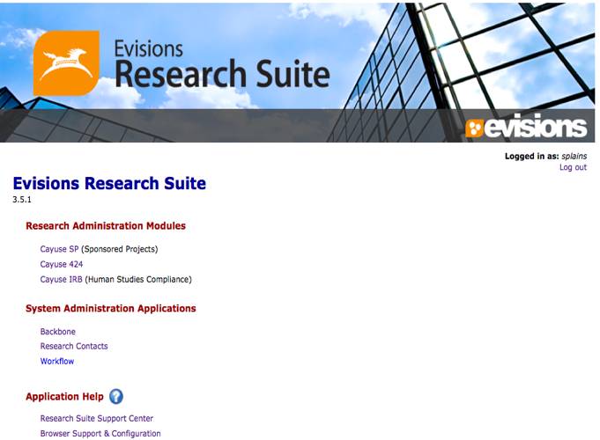
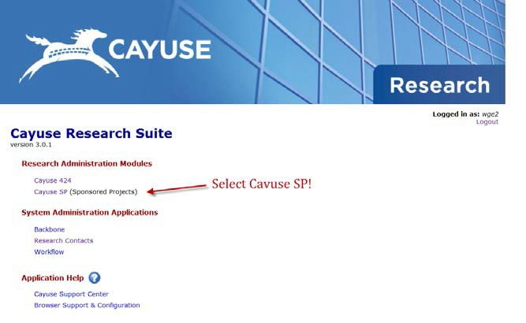

A Quick Summary
A direct link to Cayuse is provided at research.ucmerced.edu/Cayuse Click on the Cayuse logo to open a link to the UC Merced Single Sign On then enter your ID and secure password. The Research Suite screen shown on the right is the home page for Cayuse SP. Under the Research Administration Modules heading, you have the option to select Cayuse 424 or
Cayuse SP. Select Cayuse SP. You will be able to route all proposals in Cayuse SP. After all approvals are received, Sponsored Projects Office will submit the proposal according to the sponsor’s requirements.

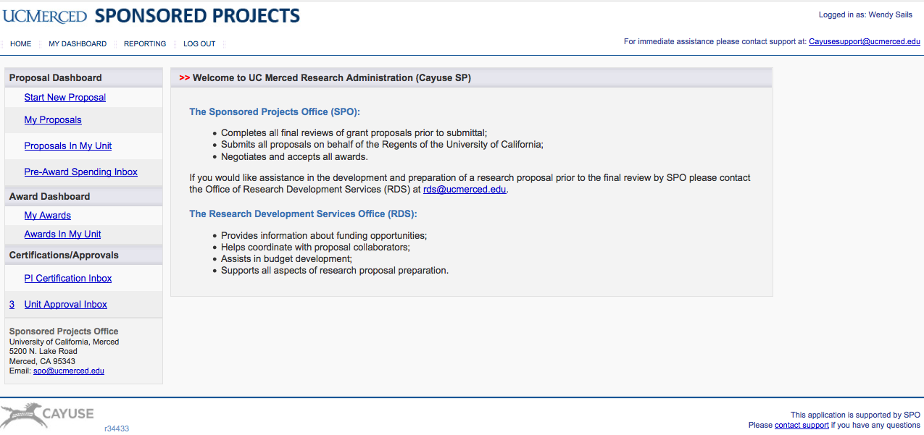

After you select Cayuse SP, a web page opens containing links to Proposal, Award, and Certifications/Approvals Dashboards. The Dashboard provides access to create, edit, and view your proposal (s). Similarly, the it also Dashboard provides access to awards for investigators, deans, and other individuals with appropriate authorizations. The Certifications/Approvals Dashboard provides access to the PI Certification Inbox (for investigators) and the Dept. Approval Inbox (deans and other approvers). The number of actions in each Inbox is indicated on the left side of the link (e.g., see the #3 beside “My Proposals” in the above figure). If you are a dean, or other approver (e.g., for cost share), open the Dept. Approval Inbox to review a proposal. Note: contact Tammy Burgess at tburgess2@ucmerced.edu or cayusesupport@ucmerced.edu questions about your access level.

Start a New Proposal File in Cayuse SP as soon as You Begin Writing a Proposal
Initiating the new proposal file in Cayuse SP is the first indication SPO has that you are preparing a proposal. That information is important for planning, to balance workloads, and to prepare for other situations, such as limited submissions where an internal review is required to select the proposal(s) that may be submitted.
Another benefit to starting the Cayuse SP proposal file is that SPO can provide you and your team early assistance and useful information about preparing and submitting your proposal. Additionally, all administrators in the department(s)/ unit(s)., who have “view proposal” access will be alerted that you are preparing a proposal and also able to assist you.

Secure Cost Share Commitments as Early as Possible
The University requires sponsored project costs to be funded to the greatest extent possible by the sponsor(s) and any cost share that is not required is discouraged. Types of internal cost share include tuition and/or fee waivers, cash match, and in-kind commitments of salary and wages.
F&A waivers or reductions by the Vice Chancellor for Research are rarely approved.

If cost share will be proposed, request approvals (e-mail, memo, etc.) from each contributing office as early as possible and upload the approval(s) in the attachments section of Cayuse SP. The budget section of Cayuse SP includes space to itemize each item of cost sharing (internal and external). As each source of cost share is entered, the office providing the cost share is automatically added to the proposal routing chain. The Vice Chancellor for Research or Director of Sponsored Research Services will certify third party cost share based on the provided documentation. Is this information accurate?
In the case of cost-share agreements among several offices at the University, the most common form of documentation is a cost-share memo signed by each office. These documents should be uploaded in Cayuse SP.

Recommended Steps for Entering Information
Information about the proposal is entered in each of the links that appear in the Item List shown to the left. Notice that the Proposal Number (in this case, 14-0129, next to the Item List) is automatically assigned in Cayuse SP; this reference number will stay with the project from proposal submission through award closeout.
Complete the General Information and Investigators/Research Team links.
Information on these pages identifies the sponsor, investigator, and managing department. What you do next depends on whether you are Principal Investigator (PI) entering information about your own proposal, or you are entering information for the PI. It is best practice to start at General Information

PI creating his own record.
If you are the PI, we strongly suggest you focus next on the compliance sections highlighted to the right: Conflict of Interest, Regulatory Compliance, Export Control, Intellectual Property, Community Benefits and Location of Sponsored Activities. These questions concern required certifications and/or contain information that is likely known only to the PI. The other sections can be completed by you (SPO recommends that you enlist the help of your Departmental Research Administrator) or the Department Research Administrator, including the budget, abstract, document uploads section, approving departments, notes section, and link to the Cayuse 424 Grants.Gov proposal). As pages are saved, a green check box appears signifying that the requested information has been provided.
If you are entering information for the PI, we suggest you focus on the Budget, Subcontractors, Application Abstract, Attachments, and Approving Departments sections and the Cayuse 424 Proposal (if applicable). Once the proposal is ready for internal routing, the PI can log on and complete the sections highlighted above at the same time that he/she certifies the proposal.
The information on any of these links can be reviewed and updated prior to submission simply by clicking the link. Be sure to save your changes before moving to a different section.
With one exception, all proposal information is entered in Cayuse SP. The exception is for grants.gov proposals that are submitted through the Cayuse 424 S2S interface; information for these proposals is entered both in Cayuse SP and Cayuse 424. See below, pp. 27-30, for detailed guidelines for preparing a Cayuse 424 grants.gov proposal.
When all sections of the Item List have green check marks, the proposal is almost ready for internal routing. Even though it’s very easy to enter and/or upload proposal information, wait to click the “Submit for Routing” link until after you’ve discussed the proposal with SPO. The reason for this is to avoid having to pull the proposal back from routing to correct errors.
Once the proposal is authorized for routing, all the information that’s been input and/or uploaded can be viewed by all internal approvers, including the PI and any other department approvers. Once all approvers have certified the proposal, the proposal gets a final review by SPO and if everything is in good order, is authorized by an Authorized Institutional Representative/Signatory (AOR) and submitted following the sponsor’s instructions.

Best Practice: Update your personal profile in Cayuse 424
One of the most common errors that we see is incorrect information about a faculty member’s title, department, and affiliation. We recommend that you review and update your information in the Investigator’s Personal Profile (found on the People tab in Cayuse 424) at least once a year, or if you have a title or department change. This information is used to auto-populate tables in Cayuse SP. The most important fields to update are the department, division, and title fields. Is this something that should be completed at central office level or departmental level.
SPO will refresh the contact list on a nightly basis to assure that contact information is accurate.

Best Practice: Use FIREFOX or Internet Explorer not Safari
Currently, Mozilla Firefox and Internet Explorer is the only software approved for Cayuse SP/424. We’ll let you know if any other software becomes approved for use.

Preparing and Routing Internal Approval Documents in Cayuse SP

General Information Section
Clicking on “Start New Proposal” opens the General Information section. This section only holds information about the proposal opportunity, sponsor, deadline, project dates, etc. Information about the Principal Investigator is entered in the next section, Investigators/Research Team.
This is the information you’ll need in order to complete the General Information section:
- Sponsor refers to the agency that will directly fund the NAU sponsored project. Click the magnifying glass iconto bring up a list of sponsors. If the sponsor is not listed, send
an e-mail to cayusesupport@ucmerced.edu to request the agency be added to the sponsor list. Please read the guidance below on Prime Funding Agency...

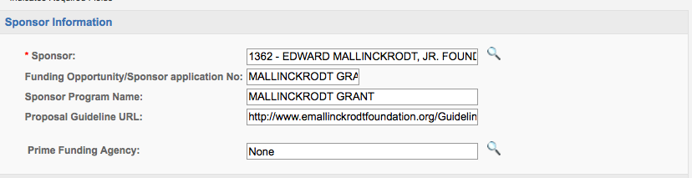

  - Funding Opportunity/Sponsor Application Number (e.g. 13-542) provided by the sponsor. Sponsor # mostly on NSF Proposals (would you like to keep this in our trainings)
  - Sponsor Program Name as listed in the funding opportunity.
  - Funding Opportunity/Sponsor Application Number (e.g. 13-542) provided by the sponsor.

  - If available, provide a web link to the Proposal Guidelines.

  - The Prime Funding Agency field is used whenever UCM will receive a subcontract or subrecipient award from an intermediate funding source (for example, UCM is included as a subrecipient in a Colorado State University (CSU) proposal to NSF. In this case, NSF is the Prime Funding Agency and the intermediate funding source, CSU, is the Sponsor). If there is no Prime Funding Agency, leave this field blank.

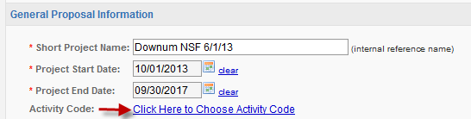

- Limited to 255 characters. Used for reference within SP; is equivalent to the Proposal name in 424(See option 3 herein). May be different from the Title of Project field below. Used different ways by units, options include: 1) the same as the Title of Project; 2) A shortened version of the Title of Project; 3) Adopt SPO’s Cayuse 424 naming convention: PI Last Name-Sponsor Name-Due Date (MMDDYYYY)-PI Initials; or 4) A nickname. Is this information accurate?
- Click on the calendar icon to enter the project start and end dates. Tip: Select the month and year first, then the day of the month.

- Click on the link to the Activity Code to select the type of activity that will be performed (usually, basic or applied research, development, instruction, or public service):
  - Academic Support category is not typically used for sponsored projects. This classification includes expenses incurred to provide support services for the institution’s primary programs of instruction, research, and public service.
  - Applied Research is conducted to gain the knowledge or understanding to meet a specific, recognized need. Includes: R&D funds received through Federal cooperative agreements and Federal contracts, all state-funded R&D and R&D funds received from private for-profit institutions, and most (but not all) funding received from federal Mission agencies such as the U.S. Department of Agriculture (USDA) or the Department of the Interior (DOI).
  - Basic Research is undertaken primarily to acquire new knowledge without any particular application or use in mind. Includes federally funded grants and R&D funded from other universities, as well as from some foundations and nonprofit organizations.
  - Development is the systematic use of the knowledge or understanding gained from research directed toward the production of useful materials, devices, systems, or methods, including the design and development of prototypes and new processes to meet specific requirements.
  - Fellowship category includes expenses for scholarships and fellowships in the form of grants that neither require the student to perform service to the institution as consideration for the grant, nor require the student to repay the amount of the grant to the funding source. In public institutions, they may result from selection by the institution or from an entitlement program.
Other classification is not typically used for sponsored projects. The category includes expenses for central, executive-level activities concerned with management and long-range planning for the entire institution, such as the governing board, planning and programming operations, and legal services; fiscal operations, including the investment office; administrative information technology (when not accounted for in other categories); space management; employee personnel and records; logistical activities that provide procurement, storerooms, printing, and transportation services to the institution; support services to faculty and staff that are not operated as auxiliary enterprises; and activities concerned with community and alumni relations, including development and fundraising.
  - Other sponsored projects category includes expenses for all activities that are part of an institution’s instruction program. Expenses for credit and noncredit courses; academic, vocational, and technical instruction; remedial and tutorial instruction; and regular, special, and extension sessions should be included.
  - Other sponsored Projects category includes expenses for activities established primarily to provide non-instructional services beneficial to individuals and groups external to the institution. These activities include community service programs (excluding instructional activities) and cooperative extension services. Included in this category are conferences, institutes, general advisory services, reference bureaus, radio and television, consulting, and similar non-instructional services to particular sectors of the community.
  - Student Services classification includes expenses incurred for offices of admissions and the registrar and activities that, as their primary purpose, contribute to students’ emotional and physical well-being and intellectual, cultural, and social development outside the context of the formal instruction program. This classification is not typically used for sponsored projects.
- Select the Proposal Type from the drop-down menu, which include the following options:

  - New – a proposal that is being submitted for the first time.
  - Preliminary proposal/letter of intent – usually the first part of a two-step process of prior review by the sponsor. May or may not require authorized official signature (check with the Sponsored Project Office).
  - Resubmission – a proposal submitted for the second time; usually prepared in response to peer reviews and therefore is improving the original submission.
  - Non-competing continuation/progress report – a proposal or request, usually in the form of a report providing information about progress and next steps, for the next increment of funding.
  - Competitive renewal – a competitively reviewed proposal requesting additional funds extending the program or research beyond the current project period.
  - Supplemental funding – a proposal for an additional scope of work and funds for an existing project during the same period of performance (POP).
  - Limited Submission – Submission to internal committee conducting a renew process to choose the proposal(s) to go forward to programs that restrict the number of proposal, applications and nomination an institute can submit to a funding agency

- If you know it, select the Instrument Type from the drop-down menu (this is not a mandatory field, and can be completed later if you don’t have the information). These are the most common award instruments:
  - Grant – an award of this type offers the most flexibility to the investigator(s) and university in administering the scope of work and project. Typical for research grants.
  - Training Grant - an award of money or other resources to provide training in a particular field, usually in areas of public need or demand. Usually from the NIH. Pays stipend, travel and other expenses of doctoral students and/or postdocs
  - Cooperative Agreement – typically used for projects/programs that will require substantial involvement from the sponsor during the performance of the activity.
  - Contract – typically used when the principal purpose of the funding is to acquire goods or services for the direct benefit or use by the sponsor; contract agreement contains more restrictive terms and conditions than grants or cooperative agreements.
  - Other – other award mechanism, sometimes used by federal agencies when the purpose of the project requires flexibility in setting the award terms and conditions.
  - Fellowship –A fellowship provides financial support to graduate students to pursue graduate studies without associated teaching or research responsibilities (as they are in a teaching or research assistantship).
  - Clinical Trial -Any research study that prospectively assigns human participants or groups of humans to one or more health-related interventions to evaluate the effects on health outcomes. Health-related interventions include any intervention used to modify a biomedical or health-related outcome (for example, drugs, surgical procedures, devices, behavioral treatments, dietary interventions, and process-of-care changes). Health outcomes include any biomedical or health-related measures obtained in patients or participants, including pharmacokinetic measures and adverse events.
- Select the way the proposal will be submitted to the sponsor:

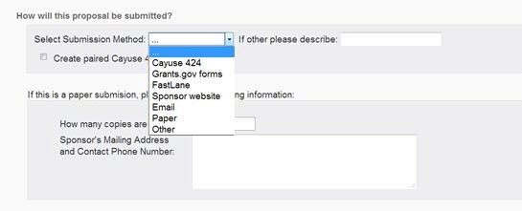

  - Cayuse 424 is used to prepare and submit most, but not all, grants.gov proposals – Check with SPO
  - Select the Grants.gov forms option only if the opportunity is not available in Cayuse 424, and the proposal will be prepared and submitted through the grants.gov web portal. We will need to create a Cayuse SP record for internal tracking
  - Most proposals are submitted directly through sponsor web portals (like NSF FastLane, NASA NSPIRES, DOE E-Grants, etc.), by e-mail, or by regular mail.
    - Select FastLane if your proposal will be submitted to the National Science Foundation.
    - Select Sponsor website if you are using a sponsor’s web portal.
    - Select e-mail if the proposal will be submitted via e-mail (in most cases, SPO will submit the proposal on your behalf).
    - If the sponsor requires a paper submission, SPO will send the proposal by overnight delivery to meet the sponsor’s submission deadline. Enter the number of copies required by the agency and provide the sponsor’s express mail address in the blocks provided.
  - Other indicates any other type of submission that is not listed or described above. Contact your Sponsored Projects Office to discuss the submission.

- In the Award Admin Dept. block, select the department/unit that will
manage the award. (This may be different from the Lead PI’s academic department.)

- The Primary Administrative Contact is typically a Business Manager within a department/unit.
- Affiliated Dept(s). Use this field to identify co-PI departments and affiliated centers and institutes. Do not use this field to identify the unit which will manage the award or to list the Lead PI’s department.
- Enter the Sponsor Deadline. If the deadline is both date and time specific, be sure to indicate whether the time is based on local (California) or a different time zone (is it best practice to put local time). Depending on daylight savings, for example, there is a two- or a three- hour time difference between California and Washington D.C. A proposal due at 5pm EDT (Eastern Daylight Time) would be due at 2pm PST (Pacific Standard Time). In Cayuse SP, enter the hour, minutes and am/pm. If it is due at 5pm, enter “5:00pm.” California is always PST.
- Enter the Title of Project that will be used on all Sponsor forms.

- At the bottom of the General Information page, you are given the options to (a) create a paired proposal (one that will be submitted through grants.gov), (b) pair a Cayuse SP
proposal with an existing Cayuse 424 proposal, or (c) un-pair a Cayuse SP proposal from a Cayuse 424 proposal. Even if your proposal will be submitted to grants.gov through Cayuse 424, we suggest you wait to create the paired proposal until you’ve completed the Cayuse SP sections. See pages 27-30 for detailed instructions for this section.
- Click the Save button at the bottom of the page. You can return to this section any time by clicking on the
General Information link.

Investigator/Research Team
The Principal Investigator (or “Lead Principal Investigator” in Cayuse SP-speak) and Co- Investigators (called Principal Investigators) are identified in this section of the Item List. The Lead Principal Investigator and Principal Investigators are the only roles that are required to certify the proposal and that are automatically added to the proposal routing chain; other roles may be added as appropriate (for example, you can list everyone who will assist with proposal preparation). Cayuse SP allows only one Lead PI to be listed, although other investigators may have the Principal Investigator or Investigator roles. You must list all Co-PIs (Investigators) involved in the project to properly trigger internal routing.
Assign “Proposal Editor” role to anyone else who will be assisting you with the proposal.

Add Personnel Information:
- The Lead Principal Investigator MUST be entered first; “Lead Principal Investigator” is the default role for this individual. This role also should be selected for a Project Director. Click in the answer block or on the magnifying glass icon to search for the PI’s last name. Most of his/her information will be auto-filled, and, except for the Lead Investigator, you must select a role before you can save the entry.
- Enter the total number of person months (AY plus summer) and the percentage that will be paid by the sponsor or cost shared. For example, a 20% course buy out and two months’ summer salary equate to (2 x 9 months) 1.8 Academic Year and 2 Summer months, or 3.8 months total.
- The Allocation of Credit block is not currently used by UCM. Is this verbiage accurate?

- After you’ve completed entering information for the Lead Principal Investigator, click the
Save Personnel button.

- Add other team members using the same procedure. Be sure to click the Save Personnel button for each entry. Enter “zero” person months and “zero” effort for anyone whose only role is assisting with proposal preparation.
These are the allowable roles, with those most commonly used shown in BOLD: Is this accurate?

  - Investigator: This individual is considered to be a primary contributor to the successful conduct of a research project; any person who is responsible for the design, conduct, or reporting of research. Select this role for non-co-PI key personnel.
  - Principal Investigator: Select this role for Co-PIs (or co-PDs). Other roles that may fall under this designation include: Research Scientist, Research Specialist, Research Associate, or Scholar. Note: ALL Co-PIs must be listed in the Investigators/Research Team section whether or not they are included in the budget. If they are not listed, they will not be included in proposal routing.
  - Postdoctoral Research Associate: This individual has received a doctoral degree and serves on the research project.
  - Fellow: This individual is a student, pre- or post-doc, applying for a fellowship or support for dissertation research whose mentor is the Lead Principal Investigator on this proposal. [Note: if the sponsor requires the proposal to be submitted by the student, the lead PI role should be selected].
  - Graduate Research Assistant: A post baccalaureate student who serves on the project.

  - Clinical Research Coordinator: This role is not typically used by UCM. No clinical research at UCM

  - Project Manager: An individual is identified in this role on a limited basis such as on program project grants.
  - Technical Staff: This individual performs standardized or routine measurements, analyses or procedures in support of the research project.
  - Undergraduate Student: This role defines an undergraduate student who does not meet the definition of Fellow.
  - Administrative Contact: This individual has proposal edit rights, but is not named in the budget (e.g., department grant manager).
  - Administrative Assistant: This role is used on a limited basis on eligible funding opportunities, for example, program project or state contracts.
  - Proposal Editor: Grants simultaneous permissions equal to the Proposal Creator in the SP record and 424 record.
  - Other Key Participant: This designation accommodates project participants whose role title differs from those above. After selecting Other Key Participant, a field labeled "Role Title" appears beneath the Role. Enter the participant's custom title into the Role Title field. The participant's department will be included in the routing list on the Approving Departments screen.
  - Other Participant (no routing): This designation serves the same purpose as Other Key Participant, except that the participant's department is excluded from the routing list on the Approving Departments screen. Select the “Other Participant” role for individuals who may assist you with proposal preparation but who do not need to be included in routing.
It’s important to complete this section accurately, since this information populates the electronic proposal routing list. Only the Lead PI and Co-PI roles certify the proposal (contrast to Other Key Personnel role, for which the department but not the individual is included in the proposal routing). After the proposal is submitted for routing, the Lead Principal Investigator and all Principal Investigators will receive an electronic notification to certify the proposal. You may add, edit, or remove individuals from the list by reopening the Investigators/ Research Team section. Be cautious about clicking on the Reset button since that will delete all prior entries for this section.

Budget Section
The budget section contains summary (not detailed) information about the initial and cumulative budgets, internal and third-party cost share/match, and additional needed resources (if applicable) for internal UCM use. These data are used in institutional reports about proposal submissions and awards which are directly accessible to investigators and other users according to their roles.

Overview:

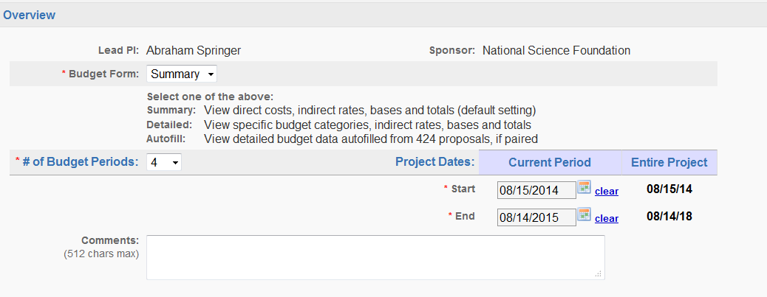

The overview section lists the Lead PI and Sponsor. If that’s correct, enter the following information in the blocks, as shown above:
- Budget Form: At this time, UCM does not use the detailed budget. Select “Summary” unless the proposal is a paired Cayuse 424 proposal and you have completed the SF424 budget pages. In this case, you have the option to auto-fill the Cayuse SP budget summary from the

Cayuse 424 grants.gov budget forms, which assures that the Cayuse 424 proposal and the information in Cayuse SP are in sync.
- Enter the number of budget periods and the start- and end- dates for the first year (current period). The program default is one budget period; adjust this block for multi-year projects.
- Click on the calendar icon to enter the start and end dates for the first budget period (Current Period). The dates for the entire project are auto-filled from the General Information section.

Cost Sharing

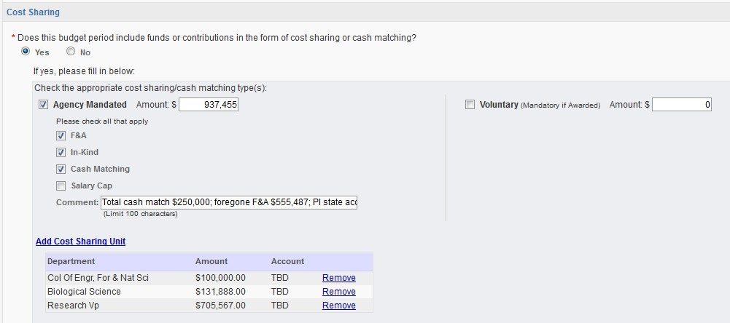
Internal cost sharing is recorded directly in Cayuse SP, creating a permanent, searchable record for each proposal. Select “yes” if the budget includes cost sharing, then click on the Add a Cost Sharing Unit link to identify the source and amount of cost share. You may add as many cost sharing units as necessary to capture all cost sharing. If the account is unknown, enter TBD. Also indicate whether the match is Agency Mandated or Voluntary. In either case, check all applicable types of cost share (F&A, In-Kind, Cash, etc.). Follow the same procedure to add each cost sharing unit, including Third Party Match. Upload cost sharing documentation in the Attachments Section.

As each cost sharing unit is added, the source department/unit, etc. is added to the electronic approval list. The proposal cannot be submitted until all cost sharing has been approved.

IMPORTANT: All cost sharing requests from the Vice Chancellor for Research (VCR), including cash match, tuition waivers, F&A waiver/reduction, etc. must be approved by the PI’s chair, director and/or dean prior to consideration by the VCR. Please submit early to allow sufficient time for thoughtful consideration of the request; late requests may be declined without consideration. Director of SPO can advise you about preparing the request.

F&A Rates

UCM’s most recent F&A rate agreement was approved by the U.S. Department of Health and Human Services (DHHS) on February 07, 2013 for a five-year period ending June 30, 2017 (or until amended). The rates are as follows:

Effective Period
Type | From | To | Rate (%) | Location | Applicable to:
PRED. | 07/01/2012 | 06/30/2013 | 55.0 | On-Campus | Organized Research
PRED. | 07/01/2013 | 06/30/2014 | 55.0 | On-Campus | Organized Research
PRED. | 07/01/2014 | 06/30/2015 | 55.0 | On-Campus | Organized Research
PRED. | 07/01/2015 | 06/30/2017 | 55.0 | On-Campus | Organized Research
PRED. | 07/01/2012 | 06/30/2017 | 26.0 | Off-Campus | Organized Research
PRED. | 07/01/2012 | 06/30/2017 | 55.0 | On-Campus | Instruction
 |  |  | 26.0 | Off-Campus | Instruction
PRED. | 07/01/2012 | 06/30/2013 | ? | On-Campus | Other Sponsored Activity
PRED | 07/01/2013 | 06/30/2017 | ? | On-Campus | Other Sponsored Activity
PRED | 07/01/2012 | 06/30/2017 | 26.0 | Off-Campus | Other Sponsored Activity
PROV. | 07/01/2017 | Until amended | Use same rates and conditions as those cited for the fiscal year ending June 30, 2017

In Cayuse SP, up to three different F&A rates may be entered. Since the UCM research rate escalates three times during the term of the agreement, many research proposal budgets will require at least two rates depending on the length of the project. The instructional and other sponsored activity rates, however, are fixed for the term of the agreement.
More information about UCM’s F&A rate is available in the Frequently Requested Information about Proposal Development and Award Management quick reference guide on the SPO web page.

Budget Categories
- Enter the total direct costs, F&A Base and Rate for the first budget period (see the example on the next page).
- Verify that the correct F&A Rate is shown. Open the Change Rate link if you need to correct the rate. If you aren’t certain which rate applies to your project, contact SPO
- These fields may be edited manually by unchecking the boxes. You will need to recalculate totals if the direct and F&A base amounts are changed.
- When developing your project budget, do not use multiple F&A rates within the same budget period unless you are advised to do so by SPO. (Explanation: budgets are estimates and expenditures may or may not correlate with an artificial allocation of costs
over the period of a year. While the use of multiple rates is typical for a cost/price analysis type proposal, SPO will advise you when that’s required.)
- Under the Entire Project column, enter the total amount (all years) of direct funding, the F&A base(s), and the F&A rate(s) as shown in the example below. Diagram must be corrected.

Example: Research budget with two different F&A rates: Diagram will be corrected

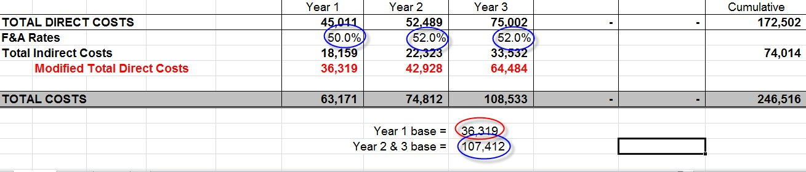

The above example is for a three-year on-campus research project with a start date of July 1, 2014. The Year 1 rate is 50% MTDC, and 52% MTDC for Years 2 and 3. The F&A base(s) for Y1 and Y2/Y3 are $36,319 and $107,412 respectively. (In contrast, an on-campus public service project would be fixed at 30.9% MTDC for the life of the project; similarly, an on-campus instructional project would be fixed at 51.2% MTDC.) This must be corrected

Transferring the numbers from the above spreadsheet to the Cayuse SP F&A rate section produces the following entries. The arrows show how the F&A rate for the first year corresponds to the F&A base shown for the Year 1 budget, and similarly, the F&A rate for Years 2-3 corresponds to the F&A base for Years 2-3. Diagram will be corrected

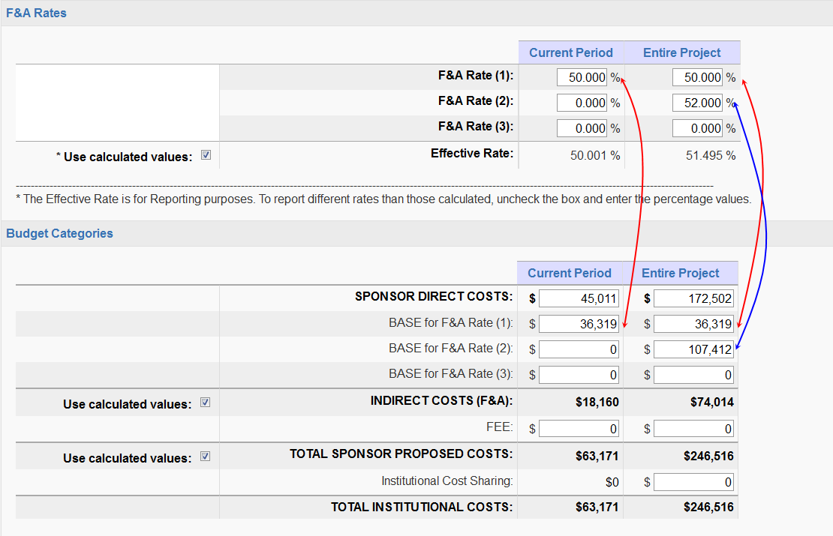

Personnel/Space/Equipment
- If additional personnel, space, or equipment from outside the University is necessary to complete the proposed project, check all that apply, and provide a justification for each item in the space provided. If space needs will involve new construction or renovation of current facilities, upload a copy of the proposed changes and approval from Facility Services in the Attachments section. Discuss the resource needs with your VC/Dean/ Director, etc. if you answer “yes” in this section PRIOR to routing the proposal for approvals.
- Once this section is complete, click the Save button. The budget section should now have a green check mark.

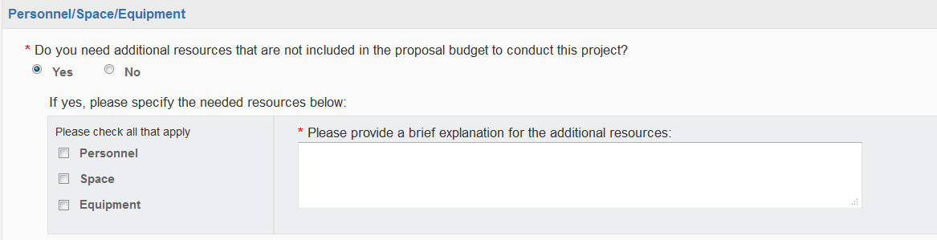

Subcontractors
If there are no subcontractors, click on the No Subcontractors button; otherwise click on the magnifying glass icon to identify the subcontractor, and then click on the Add Subcontractor button to add the subcontractor. Upload the required subcontractor documents in the Attachments section. If the subcontractor is not listed, contact your SPO to have the entity added to the vendor list.
The Compliance Sections: Conflict of Interest, Regulatory Compliance, Export Control, and Intellectual Property

The questions in these sections are required for compliance with federal regulations. Each section contains one to three questions and a contact for questions. All questions in these sections must be answered by the Lead PI. Even if someone other than the Lead PI is entering most of the information in Cayuse SP, the Lead PI must log on to answer the compliance questions when s/he logs on to certify the proposal. We are working to further streamline these questions and your suggestions are welcome.

Regulatory Compliance
If the answer to a Human or Animal Subjects question is “yes”, a new section opens to indicate whether an IRB or IACUC protocol has been submitted. If the protocol is pending, simply indicate that in the space provided. For animal subjects, each species must be listed.
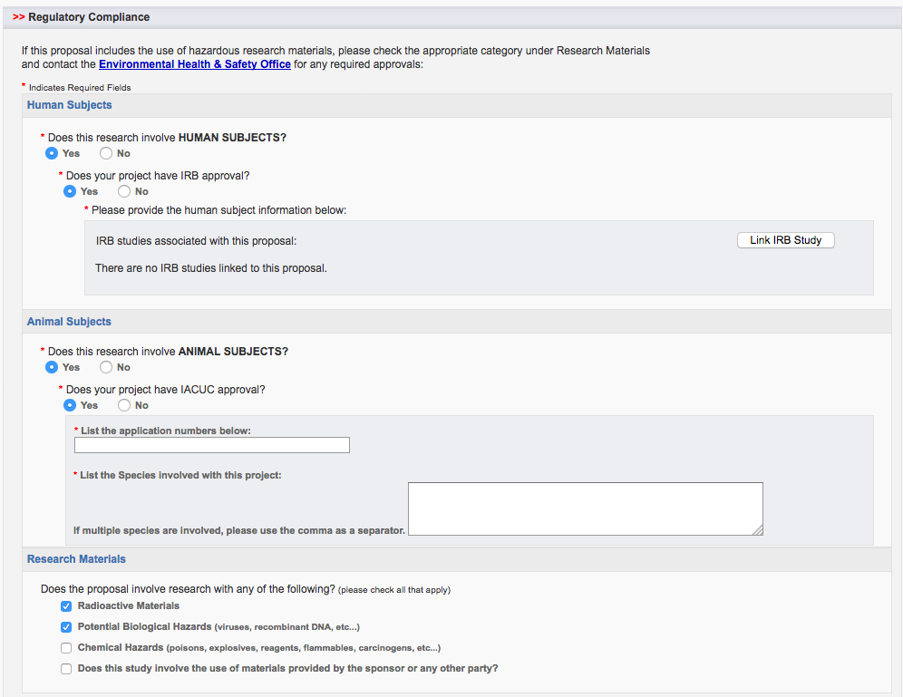

Conflict of Interest
UCM’s Conflict of Interest in Sponsored Projects Policy includes the requirement that the Lead Principal Investigator, Principal Investigators, and other key personnel review and, if necessary, update their UCM E-CERT Program disclosures PRIOR to proposal submission (not sure if this applies here). The Lead PI and Principal Investigators certify to this review when each certifies the proposal. The Lead PI is responsible for assuring that other key personnel have completed and/or updated the E-Cert prior to proposal submission. We believe the questions are self-explanatory, but if you have questions, contact your SPO. Once this section is complete, click the Save button.
- Question 1 (a) requires the Lead PI to certify that s/he has completed the E-Cert General Disclosure form and if necessary the Detailed Disclosure.
- Question 1 (b) is a certification that the E-Cert disclosure was reviewed and updated, if necessary, for this proposal submission.
- Question 1(c) should be answered “yes” only if travel was disclosed as a significant financial interest in the E-Cert disclosure. Otherwise, answer “no”.
- Question 1(d) is a certification that the Lead PI has read UCM’s COI policy, which is available at http://rci.ucmerced.edu/coi
- Question 2 concerns gifts that may have been made to the UCM Foundation this project. The answer to this question is usually “no”, but answer yes if another sponsor has made a gift to the UCM. Need to verify

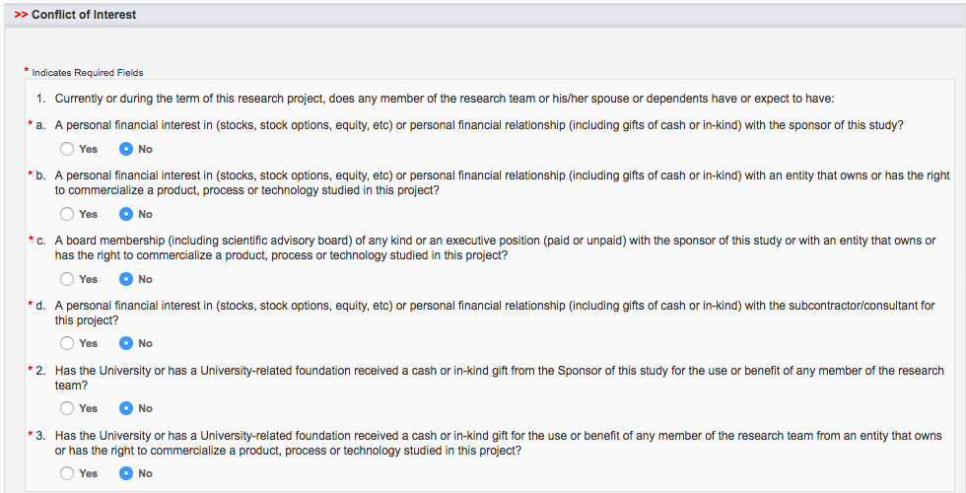

Export Control
UCM is required to comply with Federal regulations governing the distribution of controlled information and technology to foreign nationals and foreign countries for reasons of foreign policy and national security. Areas of concern include preventing terrorism, restricting exports of goods and technologies that may contribute to military potential of foreign adversaries, and protecting the loss of goods and key technologies that could affect the U.S. economy. The questions in this section are intended to assure that any potential issues related to your project are addressed prior to award.
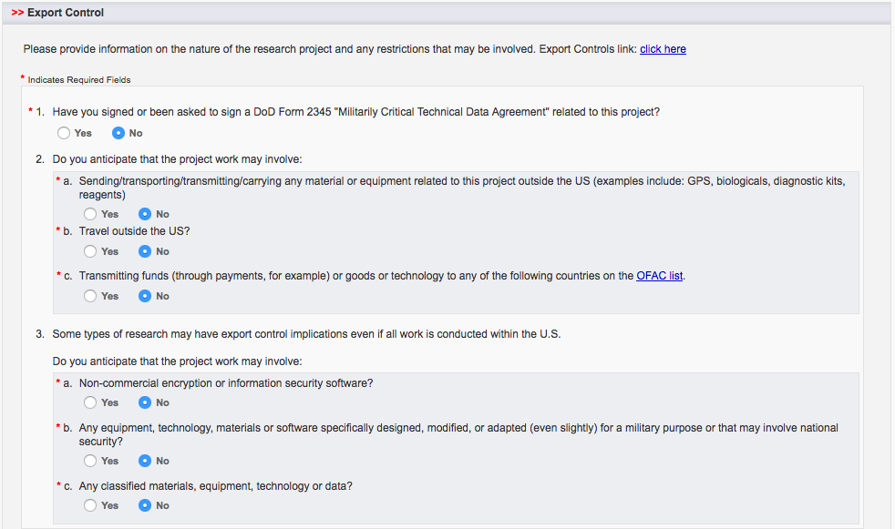

Intellectual Property
Terms and conditions in sponsored research agreements and licensing or material transfer agreements can sometimes conflict with one another, affecting the management of intellectual property. Your answers to these questions will help speed communication and avoid problems that may delay your project. If you have questions or would like more information, please contact Once this section is complete, be sure to click on the Save button at the bottom on the page.

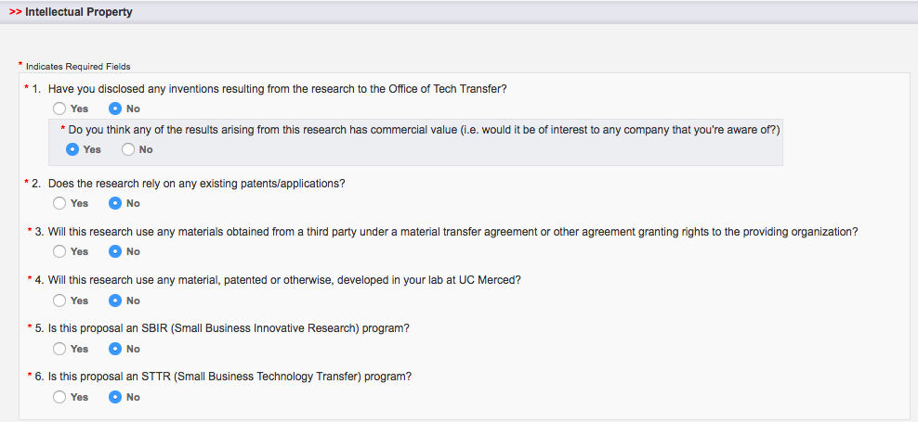

Application Abstract
Information provided in the abstract is included in many reports, including the annual research report. It also can be used for keyword searches if you choose to include a list of keywords.
Important: Please do not include proprietary information in the abstract. Important: Please do not paste the summary section from your proposal; write something brief for this section.
In this section you may also select the Field of Science (FOS) code that best describes the proposal; the categories are provided by the federal government for use in reporting research. For instruction and service projects, select the field that best describes the activity. If you don’t know, ask your Sponsored Projects Office for assistance. Remember to click on the Save button at the bottom of the page.

Attachments
The Attachments section is a key resource for investigators, departmental administrators, and approvers in Cayuse SP. The uploaded documents are a permanent record of the proposal, including the opportunity announcement, proposal, excel budget, cost share documentation, letters of support, subcontract/subrecipient commitment forms, etc. Simply select the appropriate document type, browse for the file, and upload the document.
There is no restriction on the number of attachments that may be added, and there is no restriction on file size although larger documents will take more time to upload. Any file type (with the exception of .exe) is acceptable. Attachments may be viewed by the Research Team, Approvers from approving departments and colleges, etc., and SPO. What should this say?

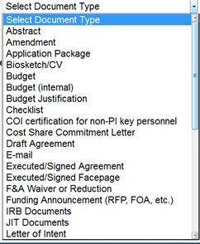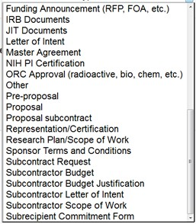

Information for Institutional Users

Community Benefits
The information in this section is related to UCM’s strategic mission and goals, and the questions are drawn from the current strategic plan. There are questions about services to Native American, Hispanic, and other minority students; undergraduate research; environmental and sustainable system, economic development, etc. One of the questions allows you to select the primary activity most closely identified with your project, and there is also space provided to select additional areas that describe your activity. Once this section is complete, click on the Save button at the bottom on the page.

Location of Sponsored Activities
NAU reports space usage biannually to the federal government and this information is also used in calculating our Indirect Cost Rate. There are four possible locations: on-campus, in-state, out-of- state, and out-of-country. You may list multiple sites under each location but the sum of all percentages in all locations must equal 100%.
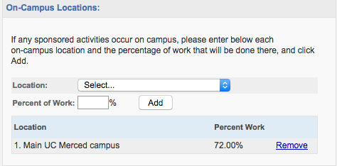

For each on-campus location (such as a faculty office or laboratory), provide the abbreviated building NAME and NUMBER, and the room number. For example, Room 3108 of the Health and Learning Center would be listed as “HLC/025-3108”. Indicate the percentage of work that will be done at that location, then click "Add". Follow a similar process to enter in-state, out-of-state, and out-of-country locations. Note the drop-down boxes to enter in-state and out-of-state information.

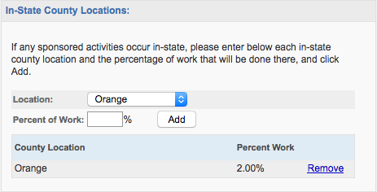

Approving Departments (and other Approvers)
Cayuse SP automatically includes the Lead Principal Investigator, Principal Investigators, Award Department (managing department), PI department(s), cost share sources, and affiliated centers and institutes in the list of Approving Departments. The Award Department is always listed first and cannot be changed or removed. The additional departments listed are those that must approve the proposal record. Each college must be manually added to the Approving Departments list, unless one is already listed because it is providing cost share. (This is a known problem and will be corrected in an upcoming update to Cayuse SP). This is corrected in 3.5.X
One change that you’ll note from Cayuse 424 is that offices rather than individuals are listed. The names of individuals only appear when the proposal is certified.
The Research Contacts list for the department/unit can include several approvers in case the primary approver is unavailable (for example, the dean and a delegate). To add or remove approvers, please send an e-mail to spo@ucmerced.edu or cayusesupport@ucmerced.edu .
Primary approvers will need to discuss with their delegates the circumstances under which they may provide the approval, since all approvers are notified of the need for the approval (and only one approval is required). Note: Cayuse SP uses the acronym “IPF” for Internal Processing Form and the term “IPF approver” to designate the individuals/offices which must approve a proposal.
The routing order for approving departments can be made sequential or concurrent by changing the number in the drop down box. The Award Department will always be listed first, but the order

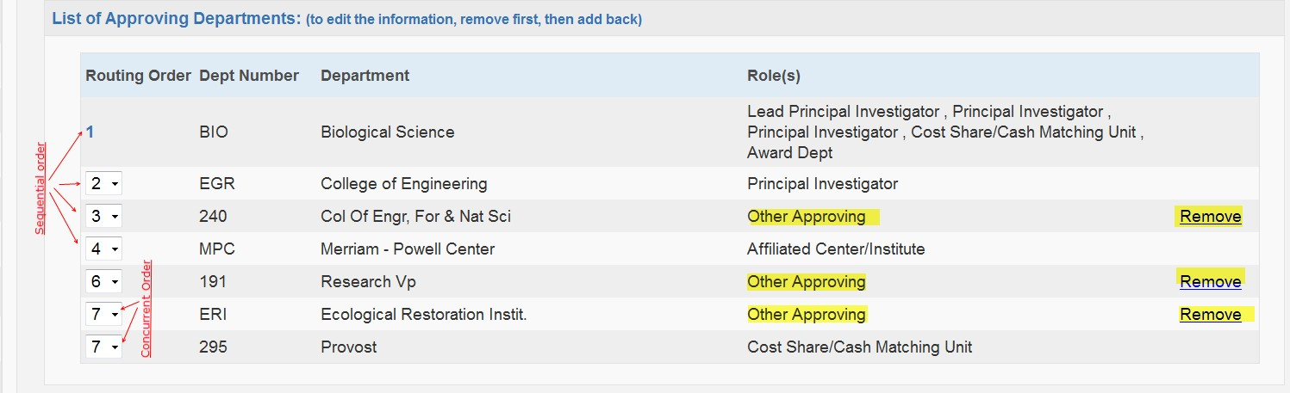
of other entries can be changed from sequential to concurrent to expedite review (this is useful in cases where multiple PIs must approve the proposal). See the examples in the figure above.
Approvers that were added based on information provided in the General Information, Key Personnel, Budget, etc. sections cannot be removed, but other approvers can be added. To add another department, click the magnifying glass icon and choose from the alphabetical list.
When all necessary departments, colleges, and other approving units are listed, click the Authorize Department Listing button. Note: you can make changes to this list until the proposal is submitted for internal review; contact your Sponsored Projects Office if changes need to be made after review is initiated.

Submission Notes
Provide any additional information, comments, or instructions regarding the proposal in this section. There is no limit on the number of notes. Notes are visible to all members listed on the Research Team, proposal approvers, and SPO, and may not be changed or deleted after creation.

Prior to Submission: Review Cayuse SP Information
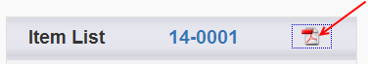
An easy way to review all the entries you’ve made in Cayuse SP, including the research team, attachments, approving departments, etc. is to print the PDF copy of the proposal summary. The proposal summary can be used by approvers to
review the proposal and can be printed as a permanent record of the approval.

Submit the Proposal for Routing
As pages are saved, a green check box appears signifying that the requested information has been provided. When all sections of the Item List have green check marks, the proposal is almost ready for internal routing. Important: Even though it’s very easy to enter and/or upload proposal information, wait to click the “Submit for Routing” link until after you’ve discussed the proposal with your Sponsored Projects Officer.
To initiate internal routing, click the Submit Proposal button. A new window opens asking you to confirm that the proposal is ready for internal review:

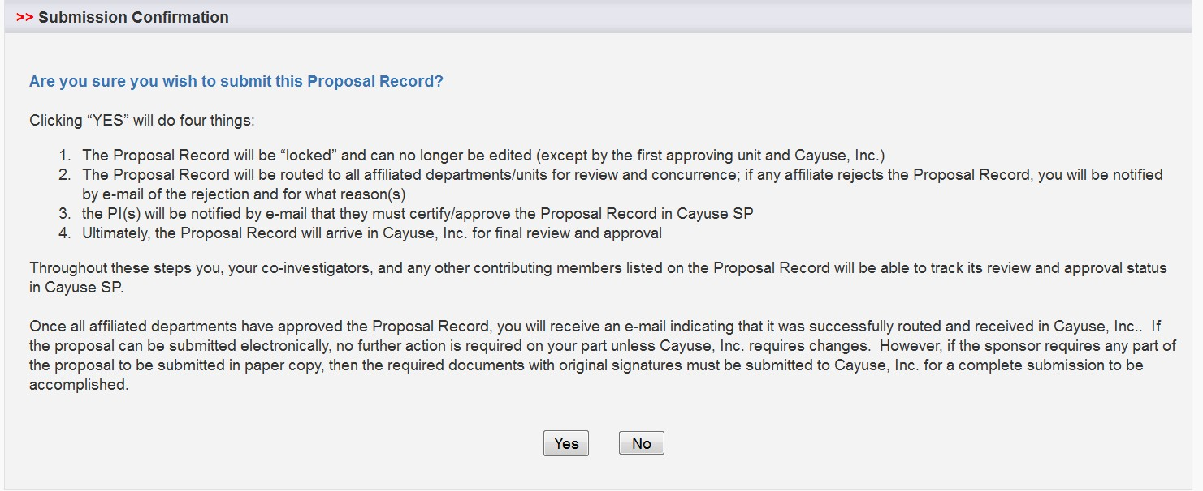

When you click on the Yes button, proposal routing commences, triggering email notifications to the Lead Principal Investigator, Principal Investigators, Dean, and other individuals whose approval is required. Each of these individuals must log in to Cayuse SP to certify the proposal and/or provide other approvals.

Routing is the movement of a proposal through the internal reviews necessary for compliance and university approvals. During the routing process, the proposal record is certified by the PI, authorized by department/school and reviewed and authorized by the Office of Grant and Contract Services. All review and approval of the proposal record is handled electronically within Cayuse SP. Paired Cayuse 424/Cayuse SP proposals also are routed in Cayuse SP. To view actions awaiting your review, open Cayuse SP and click on the link to My Proposals or Proposals in My Dept. on the Proposal Dashboard.

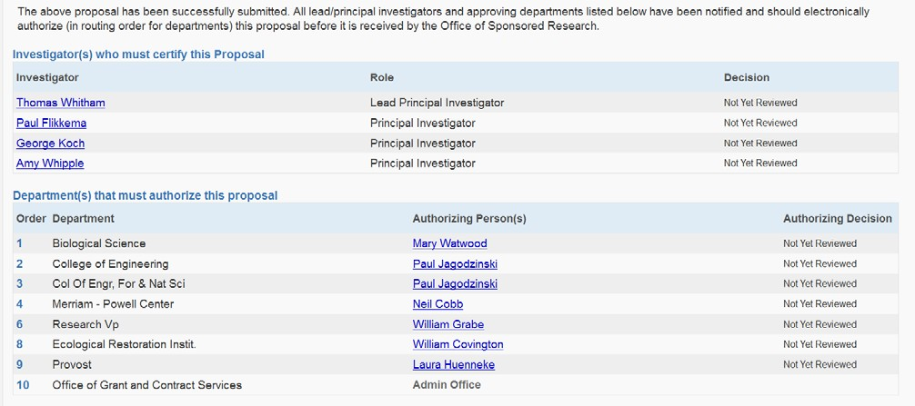

PI and Co-PI Certification
The Lead Principal Investigator and Principal Investigators review and certify the proposal for submission by opening the PI Certification Inbox.

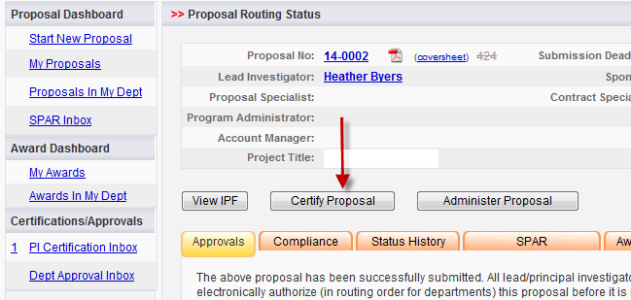

The PI certification is as follows:

In my role as an investigator, I understand and certify that:

- The information submitted within this application is true, complete and accurate to the best of my knowledge. Any false, fictitious, or fraudulent statements or claims may subject me to criminal, civil, or administrative penalties.
- I am responsible for the scientific/programmatic, fiscal and ethical conduct of the project and for providing the required deliverables if an award is made.
- I will comply with all relevant state and federal regulations, Arizona Board of Regents (ABOR)/NAU policies, and contractual obligations in administering the resultant award.
- I am not current debarred or suspended by the Federal Government.
- I am award of federal lobbying requirements and am in compliance or have disclosed any lobbying activity.
- I am not delinquent on any federal debt, such as taxes, student loans, etc.
- I will work to ensure that my relationship with the sponsor of this project is either free of conflict of interest or consistent with a previously disclosed conflict of interest management plan.
- I acknowledge my obligation to assign to the Arizona Board of Regents (“the Board”) any rights in Intellectual Property in which the Board claims an ownership interest under ABOR Policy 6-908 (“Policy”) and by submitting this form, I acknowledge that such assignment has been made in accordance with the Policy.
- I understand that unallowable or unpaid costs under an award for this project may be transferred from the project account to a local account.

$Type equation here.$Dean/Director and other Approvers
Once the proposal has been approved by the Principal Investigator, other internal approvers receive an email notification and link to Cayuse SP. These Approvers should open the Department (Dept.) Approval Inbox to review the proposal. The Dean/Director, other approver certification is shown below.

As Dean/Chair/Director, I understand and assume the following responsibilities with respect to this application:

- The project is an appropriate activity within the Department/Center/Institute; and supports NAU’s mission.
- The Department/Center/Institute has agreed to provide the resources identified in this application.
- When applicable, these resources could include cost sharing and the responsibility for unallowable or unpaid costs.
- When applicable, my authorization on this form indicates approval for faculty buyout and level of effort as stated in the proposal and proposal budget.

As each individual certifies the proposal, the date and time of the approval is indicated on the routing form. After all required approvals are received, the proposal is routed to SPO for final review, and then submitted for approval by an individual authorized to approve documents on behalf of the UCM.
When all approvals have been provided, the proposal is submitted by the method you identified in the General Information section of the Item List.

Cayuse 424 Grants.Gov Proposals

Cayuse SP does not change the way that S2S grants.gov proposals are submitted, but the procedures have changed. Even if you’re very familiar with Cayuse 424 grants.gov submissions, please review this section carefully.
All proposals, including Cayuse 424 grants.gov proposals, are begun in Cayuse SP. The Cayuse SP proposal is “linked” or “paired”, signified by the pairing icon, to a Cayuse 424 grants.gov application form set. When the Cayuse 424 proposal is complete and all required internal approvals have been given, the completed proposal will be submitted to grants.gov using the
Cayuse 424 system-to-system (S2S) interface.

When you begin a proposal in Cayuse SP, the General Information tab is the first section you complete. If you are preparing a Cayuse 424 grants.gov proposal, you may create a new “paired” proposal; pair a Cayuse SP proposal with an existing Cayuse 424 proposal, or un-pair a Cayuse SP proposal from an existing Cayuse 424 proposal as shown in the graphic below. The link can be created or removed at any time by returning to this section of the General Information tab.

Steps for Linking Cayuse SP with a Cayuse 424 Grants.Gov Opportunity
When you click on the “Create a Paired Proposal” link, a Create Proposal window opens as shown below. For grants.gov submissions through Cayuse, select Grants.gov, and then click on the Create button, which opens the list of opportunities shown on the following page.

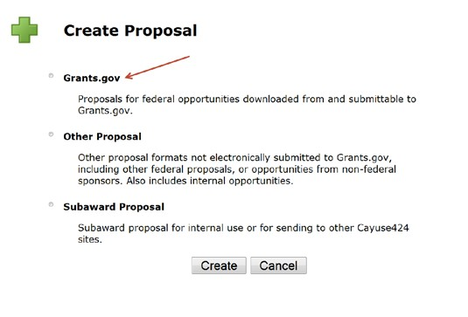

Select the applicable Opportunity Number by clicking on the icon next to the Opportunity Number. If the funding opportunity does not appear in the list, contact your Sponsored Projects Offoce to verify that a Cayuse 424 form set is available. If it is not available, the opportunity will have to be downloaded from and submitted directly to grants.gov.

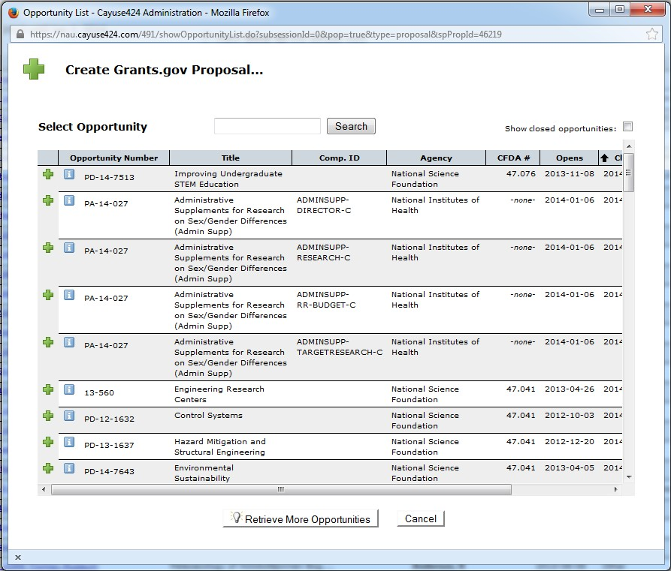

After you select an opportunity, the Create Grants.gov Proposal window opens as shown below. Enter the same short Proposal Name that you entered in Cayuse SP (Last Name, Sponsor, Deadline) and select the lead PI, the Default IDC Rate, Number of Budget Periods, and Validation Type. Then click the Create Proposal button to open the Cayuse 424 grants.gov application form set.

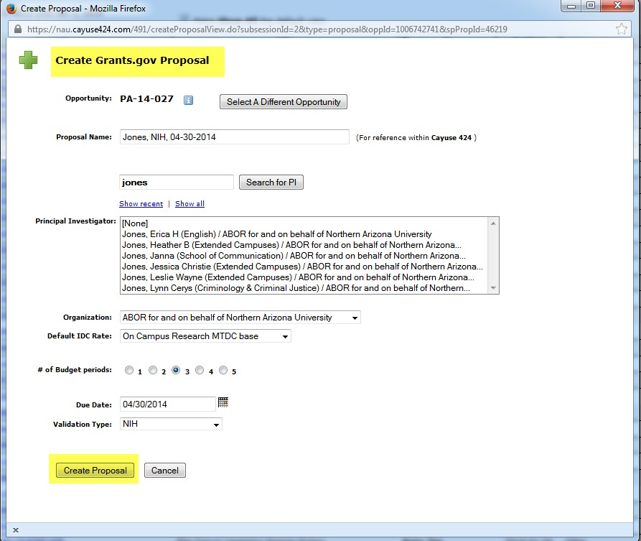

Below is an example of a Cayuse 424 grants.gov form set. As with all grants.gov proposals, you will complete the required forms and load all sponsor-required attachments in the Cayuse 424 application form set. One important difference between Cayuse 424 and Cayuse SP is that you will not load any attachments in the Cayuse 424 Summary – Documents section. Instead, load these attachments in Cayuse SP.

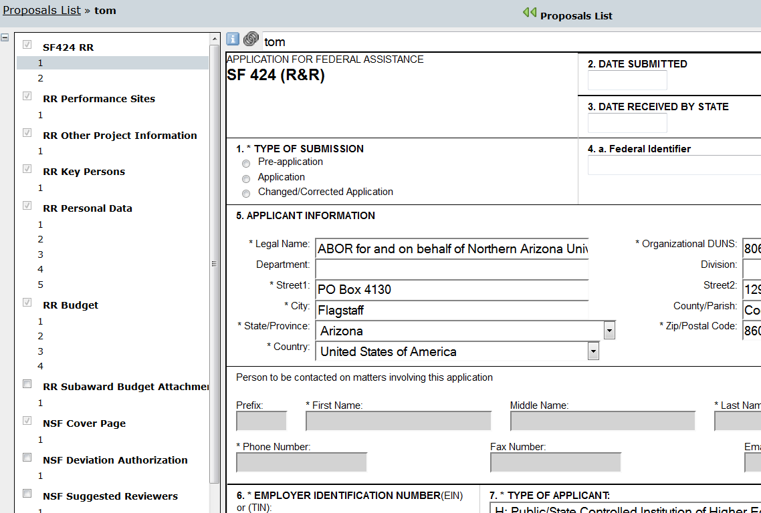

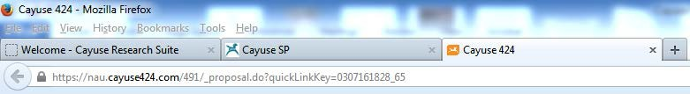
Tip: As shown above, keep both the Cayuse SP proposal file and the linked Cayuse 424 file open in your browser, switching back and forth by clicking on either tab.
After initiating internal proposal routing, the Cayuse 424 proposal file is locked. Tip: To continue work on your proposal during the internal routing period, un-pair the Cayuse 424 proposal prior to routing (click on the “Un-pair with 424 Proposal” in the General Information section of Cayuse SP). Your GCA/GCC will guide you through this process, which is intended to maximize the time you have available to finalize the technical proposal. After proposal routing is completed, the Cayuse 424 grants.gov proposal can be “re-paired” with the Cayuse SP file by the same method.
That’s it. Questions? Call 209-285-8289 or e-mail spo.ucmerced.edu or contact your Sponsored Projects Officer directly

